**SOLUTION ARCHITECTURE**

7155019106018 – JOTHI KRISHNA T

715519106020 – KARTHIKEYAN A

715519106031 – NITHIYANANTH S

715519106059 – VIPIN L

**Gas Leakage Monitoring And Alerting System** **For Industries**

**Problem Statement:**

To be able to work effectively on major crises rather than worrying about monitoring or gas leaks, workers in busy industries that are packed with gas, whether harmful or harmless, need a way to continuously monitor their gas pipelines and detect early if there is any leakage of gas in their surroundings. This will reduce the manpower of that industry and foster peace.

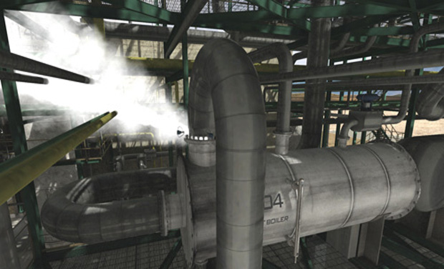

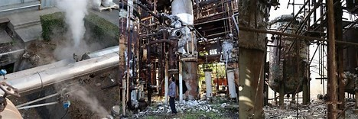

**Solution Statement:**

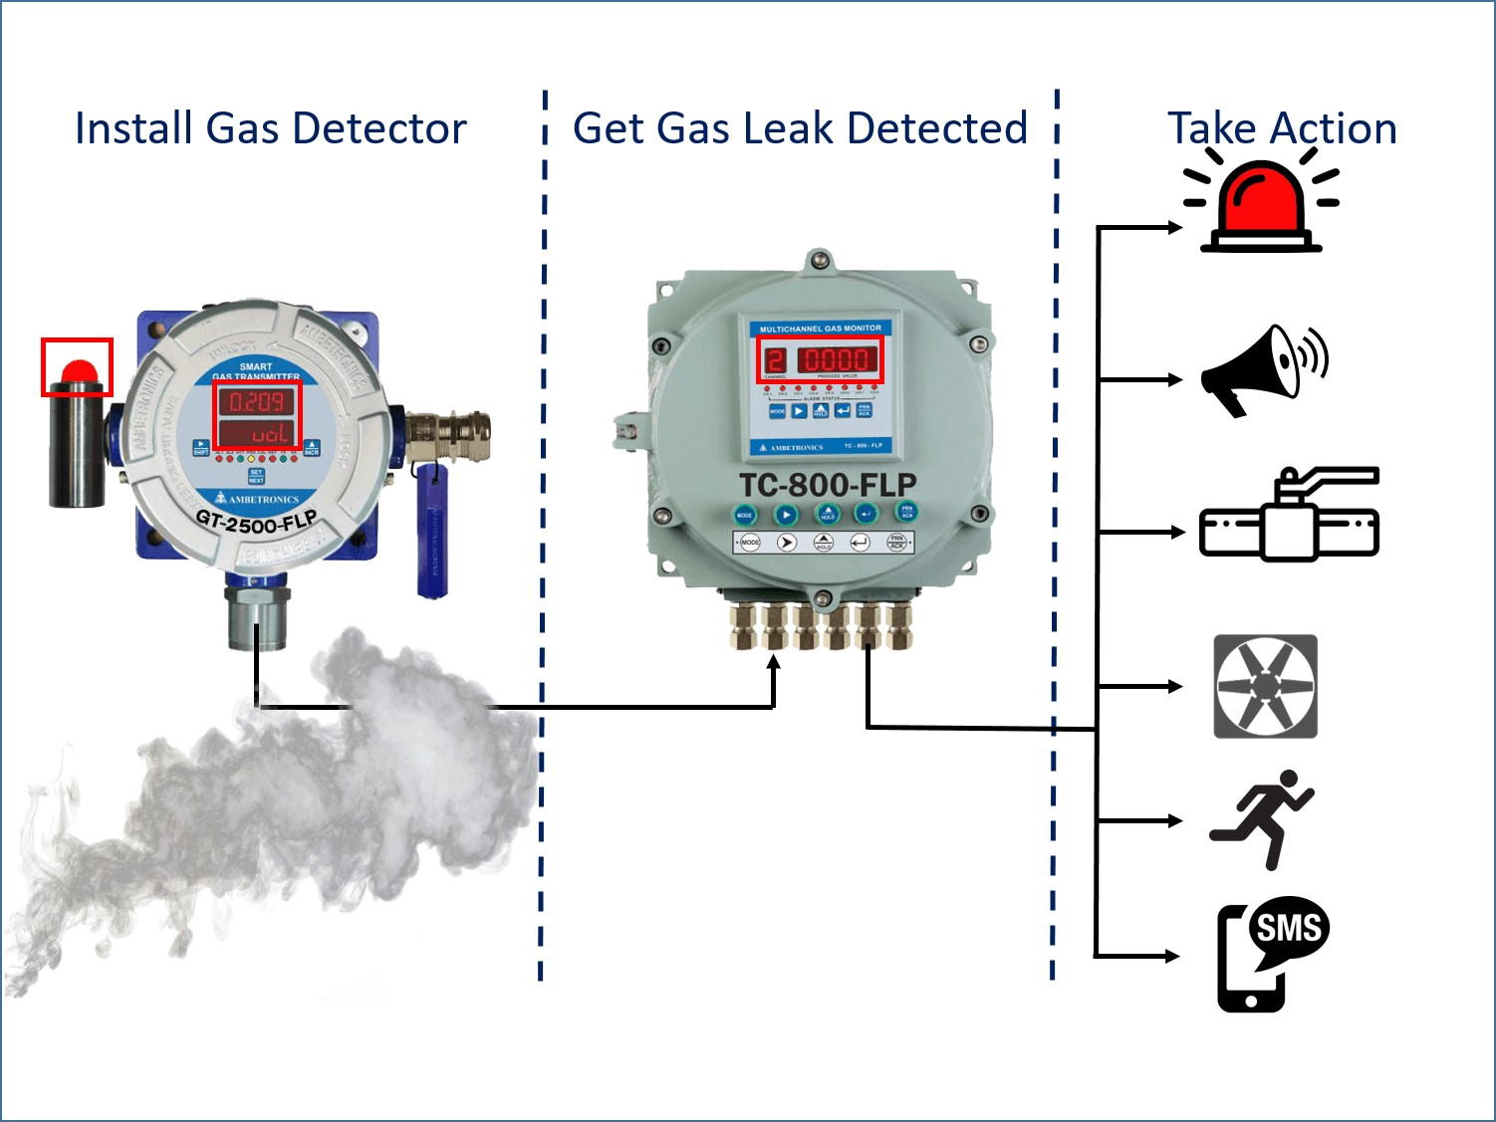

The system might be viewed as a modest attempt to link up the principal gas detection techniques now in use with a mobile platform coupled with IoT platforms. One metre around the rover, the gases are detected, and the sensor output data is continually sent to the nearby server. Stray gases are also detected because MQ sensors' accuracy isn't up to par, which causes some mistake in the sensors' outputs, particularly in the case of methane. Additionally, the storage and availability of hazardous gases like hydrogen sulphide makes it difficult to test the integrated gear. The complexity of system maintenance and material selection for the system in the event of corrosive gases arises from the fact that the system functions outside the pipeline.